ReactDOM.render is no longer supported in React 18. Use createRoot instead. Until you switch to the new API, your app will behave as if it’s running React 17. Learn more: https://reactjs.org/link/switch-to-createroot
React 18 introduces a new root API which provides better ergonomics for managing roots. The new root API also enables the new concurrent renderer, which allows you to opt-into concurrent features.
// Before
import { render } from 'react-dom';
const container = document.getElementById('app');
render(<App tab="home" />, container);

// After
import { createRoot } from 'react-dom/client';
const container = document.getElementById('root');
const root = createRoot(container);
root.render(<App />);

Suppose we want to make a component for an HTML form. Let’s say our form will have two input fields and a submit button. We can create a form component as shown below:
Filename- index.js:

import React from 'react';
import {createRoot} from 'react-dom/client ';

const rootElement=document.getElementById(“root”);
const root = createRoot(rootElement);

const Form=()=>
{
return (
<div>
<input type = "text" placeholder = "Enter Text.." />
<br />
<br />
<input type = "text" placeholder = "Enter Text.." />
<br />
<br />
<button type = "submit">Submit</button>
</div>
);
}
//ReactDOM.render(
root.render(
<Form />);

Output:
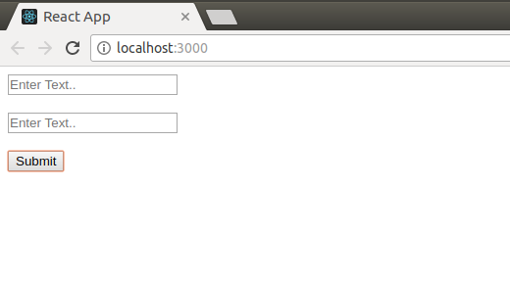
The above code works well to create a form. But let us say now we need some other form with three input fields. To do this we will have to again write the complete code with three input fields now. But what if we have broken down the Form component into two smaller components, one for the input field and another one for the button? This could have increased our code reusability to a great extent.
below code the component Form is broken down into smaller components Input and Button.
Filename- index.js:

import React from 'react';
//import ReactDOM from 'react-dom';
import {createRoot} from ‘react-dom/client’;
const rootElement = document.getElementById(“div”);
const root = createRoot(rootElement);
// Input field component
const Input=()=>
{
return(
<>
<input type="text" placeholder="Enter Text.." />
<br />
<br />
</>
);
}

// Button Component
const Button=()=>
{
return <button type = "submit">Submit</button>;
}

// Form component NOTE: Input component is used 2 times, Button
const Form=()=>
{
return (
<div>
<Input />
<Input />
<Input />
<Button />
</div>
);
}

root.render(
<Form />
);
Output:

Keys and map function
Keys allow React to keep track of elements. This way, if an item is updated or removed, only that item will be re-rendered instead of the entire list.
Keys need to be unique to each sibling. But they can be duplicated globally.
Generally, the key should be a unique ID assigned to each item. As a last resort, you can use the array index as a key.

import React from 'react';
import ReactDOM from 'react-dom/client';

function Car(props) {
return <li> { props.brand }</li>;
}

function Garage() {
const cars = [
{id: 1, brand: 'Ford'},
{id: 2, brand: 'BMW'},
{id: 3, brand: 'Audi'}
];
return (
<> <h1>List of Different Car Brands</h1>
<ul>
{cars.map((car) => <Car key={car.id} brand={car.brand} />)}
</ul>
</>
);
}

const root = ReactDOM.createRoot(document.getElementById('root'));
root.render(<Garage />);

